Q1a – Which 20% of branches are underperforming? Evident in “closed complaints without relief” and negative customer service?

A - There is no column in common between the 2 tables Events and Reviews which has the necessary information. I have tried using Union all but keep getting an error message

Msg 245, Level 16, State 1, Line 5

Conversion failed when converting the nvarchar value 'Closed with explanation' to data type tinyint.

Hence I have decided to create two separate queries and try to answer the question based on each.

From the table Reviews there are two scores for ratings – 1 and 5. I made the assumption that 1 is the worst as these scores are associated with poor reviews in the text column “Review”

I selected the districts with the highest number of 1 ratings and ranked them

I then counted the number of distinct districts – 78. External maths show that 20% of 78 is 15.6 (call it 16)

Hence the top 16 are in the rankings.

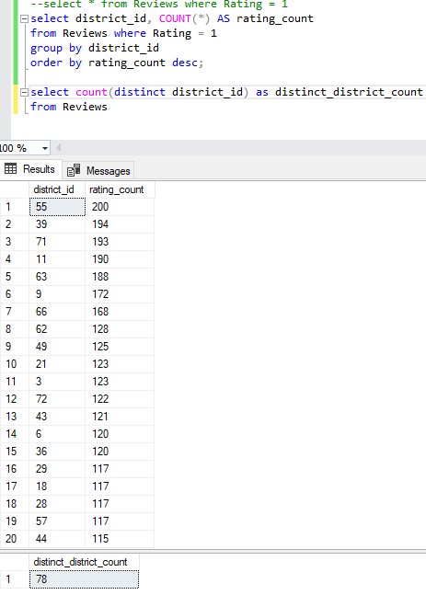

Or I can try and do it all in one command

select district_id, COUNT(*) AS rating_count

from Reviews where Rating = 1

group by district_id

order by rating_count desc

LIMIT TOP 20 PERCENT;

Also tried

But I couldn’t get it to work. Kept getting incorrect syntax near LIMIT

Q1a - Evident in “closed complaints without relief”

Tables (Client and Events) linked via Client-id column I was able to sort the districts into order with the most values ‘closed without relief’

I then added some code to rank them but only include the top 20%

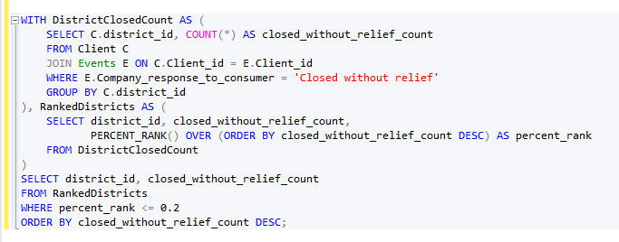

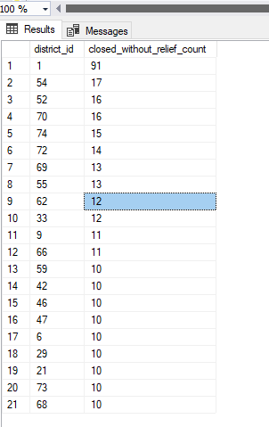

Q1ai – Can we rank servers’ performance according to call duration and outcome?

Under the server column there are lots of entries with ‘no server’ or Null. I assume these are calls where no server was available. Hence, for the purposes of this query I will ignore them.

Also, the only hang or phantom entries were against these so I will also ignore them

